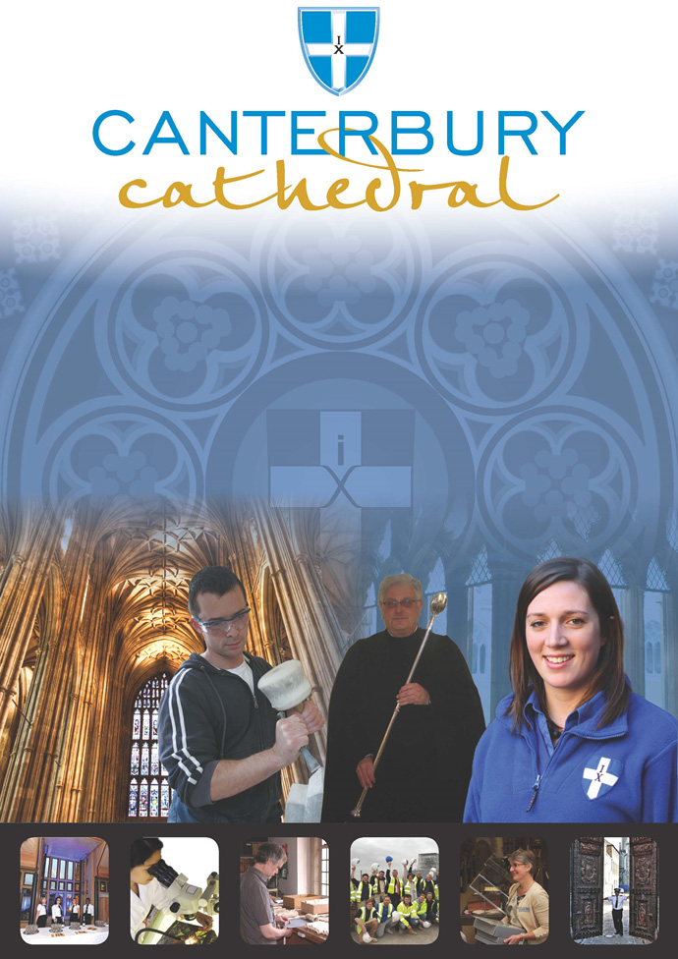

PROFILE OF CANTERBURY CATHEDRAL
St Augustine, the first Archbishop of Canterbury, arrived on the coast of Kent as a missionary to England in 597 AD. He came from Rome, sent by Pope Gregory the Great. It is said that Gregory had been struck by the beauty of Angle slaves he saw for sale in the city market and dispatched Augustine and some monks to convert them to Christianity. Augustine was given a church at Canterbury (St Martin’s, after St Martin of Tours, still standing today) by the local King, Ethelbert whose Queen, Bertha, a French Princess, was already a Christian. This building had been a place of worship during the Roman occupation of Britain and is the oldest church in England still in use. Augustine had been consecrated a bishop in France and was later made an archbishop by the Pope. He established his seat within the Roman city walls (the word cathedral is derived from the Latin word for a chair ‘cathedra’, which is itself taken from the Greek ‘kathedra’ meaning seat.) and built the first cathedral there, becoming the first Archbishop of Canterbury. Since that time, there has been a community around the Cathedral offering daily prayer to God; this community is arguably the oldest organisation in the English speaking world. The present Archbishop, The Most Revd Justin Welby, is 105th in the line of succession from Augustine.
Augustine’s original building lies beneath the floor of the nave– it was extensively rebuilt and enlarged by the Saxons, and the Cathedral was rebuilt completely by the Normans in 1070 following a major fire. There have been many additions to the building over the last nine hundred years, but parts of the quire and some of the windows and their stained glass date from the 12th century.
By 1077, Archbishop Lanfranc had rebuilt it as a Norman church, described as “nearly perfect”. A staircase and parts of the North Wall – in the area of the North West transept also called the Martyrdom – remain from that building.
During the Second World War, the Precincts were heavily damaged by enemy action and the Cathedral’s Library was destroyed. Thankfully, the Cathedral itself was not seriously harmed, due to the bravery of the team of fire watchers, who patrolled the roofs and dealt with the incendiary bombs dropped by enemy bombers.
Today, the Cathedral stands as a place where prayer to God has been offered daily for over 1,400 years; nearly 2,000 services are held each year, as well as countless private prayers from individuals. The Cathedral offers a warm welcome to all visitors – its aim is to show people Jesus, which we do through the splendour of the building as well as the beauty of the worship.

THE WORK OF THE CATHEDRAL
The work of the Cathedral is carried out by over 300 paid staff, supported by some 500 volunteers. The ‘corporate body’ responsible for the management of the Cathedral is the Chapter of Canterbury who are advised by the Cathedral Council and the College of Canons.

The Chapter of Canterbury (Chapter)
The Chapter are responsible for all aspects of the day-to-day management of the Cathedral. Chapter comprises the Dean, the Residentiary Canons, the Receiver General and four additional persons appointed by the Archbishop.

The Cathedral Council
The Council represents the Cathedral community as well as the wider local and regional community. It has 20 members, drawn from a wide variety of organisations. Its duty is to further and support the work of the Cathedral Church in spiritual, pastoral, evangelistic, social and ecumenical areas.

The College of Canons
The College of Canons is composed of 30 Honorary, Lay and Provincial Canons, appointed by the Archbishop and it supports the life of the Cathedral in many different ways.

The Cathedral Trust
The Cathedral Trust is a separate charity that is solely for the benefit of the Cathedral. Since 1974, it has assisted with the restoration, maintenance and improvement of the fabric and contents of Canterbury Cathedral and the provision, promotion and encouragement of music
The Cathedral is well-known all over the world and we welcome more than 1 million visitors and worshippers every year. The Cathedral is more than just a beautiful old building and heritage site; it is a working, living church which maintains a tradition of welcome and worship that has been practiced here for over 1400 years.

Friends
The Friends of Canterbury Cathedral was founded in 1927 by the distinguished scholar and poet Dean George Allen Kennedy Bell. The Organisation was the first of its kind in the world.
The Friends are the Cathedral’s fan club. Admirers of the building, its history and its community, Friends are a part of the Cathedral and work together to preserve it forever, contributing financially - and directly – to many individual and vital projects.

The Cathedral Shop
The Canterbury Cathedral Shop is a large gift shop in the heart of the city of Canterbury. It has an impressive range of high quality gifts, mostly British, and their own exclusive award winning designs.
The Shops wide range of merchandise includes replica historical artefacts, books and CD’s of the world-famous Canterbury Cathedral choir.

CANTERBURY CATHEDRAL LODGE
General Manager
Image Database Archivist / Cataloguer
Inventory Administrator
Kitchen Porters

Banqueting / Bar staff

Housekeepers

Housekeeping Supervisor

Receptionists

Commis Chef

Head Chef
Sales and Marketing Manager
Head Housekeeper
Senior Receptionist

Accommodation Manager
Breakfast Supervisor

Conference & Events Coordinators
Catering Manager
Night Porters

Conference & Banqueting Supervisors

Chef de Partie

Sous Chef

JOB PROFILE
To support the Head and Sous Chef and in their absence take full responsibility for the management of the kitchen. To assist in the preparation and cooking of all foods, ensuring the highest standards of food presentation and quality at all times whilst strictly adhering to all current health and hygiene regulations.

The Chef de Partie reports to the Head Chef.

PRINCIPAL TASKS
- To be hands-on at all times, including preparation.
- To maintain high levels of productivity and food standards during service.
- The preparation and cooking of all dishes in accordance with the set pre specified formulas in the Centre and other areas catered by the Canterbury Cathedral Lodge within the Cathedral Precincts.
- To play an active role in the development and implementation of new menu concepts.
- To liaise with the Restaurant and Conference & Banqueting personnel to ensure all meals are presented at their optimum, ensuring a smooth flow of service from front of house and throughout the kitchen.
- To keep abreast of all current health and hygiene regulations ensuring kitchen is ready to pass any in-house or government body inspections at all times.
- To maintain the system for recording, checking and labelling all food stuffs, oven, fridge and delivery vehicle temperatures.
- To monitor all suppliers visiting premises and periodically checking cleanliness hygiene standards of delivery vehicles.
- To ensure adequate supplies of all non-food stocks such as machine detergents and all cleaning materials.
- To be prepared to undertake training as directed by the Head Chef, Sous Chef and General Manager.
- To have a good understanding of HACCP procedures.
- To be aware of current hygiene, health & safety policy and fire procedures.
- To ensure that the premises are a safe environment for everyone who uses them.
- As an employee of the Chapter of Canterbury to fully endorse, understand and exercise the roles and responsibilities contained within Chapter’s Health and Safety policy which is set out in the Staff Handbook.
- To assist in other departments on occasions when necessary.
- To carry out any reasonable task or duty that may be required by the Head Chef, Sous Chef, General Manager or Chapter.

PERSON SPECIFICATION
The personal specification below indicates the qualifications, experience, knowledge and skills required to undertake the role effectively.

ESSENTIAL KNOWLEDGE AND SKILLS
- City and Guilds 706/3, NVQ Level 2 in Catering & Hospitality or Diploma in Professional Cookery levels 1 & 2 or equivalent.

- Have a proven background / experience of working in a fast paced kitchen or similar operation.

- Up to date with food safety, fire and health and safety legislation.

- Food Hygiene Certificate.

- Understanding of and sympathy with the aims and purposes of the Cathedral, its mission and ministry.

DESIRABLE KNOWLEDGE AND SKILLS
- Intermediate Food Hygiene.

- 1st Aid Certificate.

PERSONAL ATTRIBUTES
- Well presented, organised and self- disciplined.

- Must be reliable and flexible in approach to work to cater to the varying operational requirements which may change at short notice, include weekends and working on statutory holidays.

- Flexible and adaptable to accommodate a diverse range of customer requirements.

- Must be fit and active enough to carry out the responsibilities of the position which will include heavy lifting and bending.

TERMS AND CONDITIONS

Grade
6

Salary
£19,776 per annum.

Annual pay reviews
Each year, Chapter consider if a global pay rise is to be awarded to all staff. If a rise is agreed, this is applied to pay from 1st April.
All staff with six months service or more on the 1st April will be eligible for any increase applied. Staff who are not eligible on the 1st April will instead be entitled to any increase applied after 6 months service.
E.G. a member of staff joining in January will not receive a pay rise on 1st April along with other staff. They will receive this rise in July, 6 months after starting.

Working hours
Approximately 40 hours per week including weekends, public holidays, early and late duties. The position holder should be flexible in their approach to hours worked as these will depend on operational needs.

Annual holiday

Based upon the hours stated above, the annual entitlement is 25 days plus 8 public holidays and 2 Chapter Days.

Probation Period
All new posts are subject to a probation period. New staff will meet regularly with their line manager to assess both formally and informally progress on work and performance.

Training
Training needs are assessed continuously and appropriate on the job training is provided.
Workwear
Protective clothing will be provided.

Pension scheme
The Chapter of Canterbury offer a Stakeholder pension to all employees. Your age and salary will determine if you are to be automatically enrolled into the pension scheme. Chapter contribute 7½ % of salary into a Stakeholder Pension Scheme. Staff in the pension scheme are insured against death in service 3 x annual salary to the age of 70.

Parking
Chapter is not able to offer staff parking on site.

Staff benefits
We are able to offer a range of staff benefits including discounts in local shops, restaurants and sports centres.

Additional Requirements
To ensure that you have no medical condition that can be caused by or made worse by the work you do, upon appointment the post holder will be required to complete a medical questionnaire to confirm that the applicant is sufficiently fit enough to fulfil the requirements of the position which will include food handling, and heavy lifting and if thought necessary will be required to attend a medical by our Occupational Health Service Provider. This may be repeated on an annual / ad hoc basis.

EQUALITY STATEMENT
The Chapter of Canterbury recognises that discrimination and victimisation is unacceptable and that it is in the interests of the organisation and its employees to utilise the skills of the total workforce. It is the aim of the organisation is to ensure that no employee or job applicant receives less favourable facilities or treatment (either directly or indirectly) in recruitment or employment on grounds of age, disability, gender / gender reassignment, marriage / civil partnership, pregnancy / maternity, race, religion or belief, sex, or sexual orientation.
Personal Data
As your employer, the Chapter of Canterbury needs to keep and process information about you for normal employment purposes. The information we hold and process will be used for management and administrative use only. To comply with the General Data Protection Regulations, your acceptance of these terms and conditions gives your consent for your data to be processed.
October 2019
This job description is provided to assist the post holder to know their principal duties. It may be amended from time to time in consultation with the post holder, by, or on behalf of, the Head of the Department, without change to the level of responsibility appropriate to the grading of the post.

HOW TO APPLY

Application details can be found at:

http://canterbury-cathedral.org/community/employment

The closing date for this post is:

Wednesday 23rd October 2019

